ATTENTION!!!!!!!!!!!!! THERE IS THREE PROBLEMS MOST OF THEM I HAVE DONE BUT IM HAVING TROUBLE FIGURING OUT THE REST SO PLEASE HELP!

Treasury Stock Transactions
Below are the stock transactions of Seoul Company during 2014:

Oct. 1 | Purchased 1,600 shares of its own $2 par value common stock for $20 per share, the current market price.
17 | Sold 420 shares of treasury stock purchased on October 1 for $25 per share.
21 | Sold 800 shares of treasury stock purchased on October 1 for $18 per share.

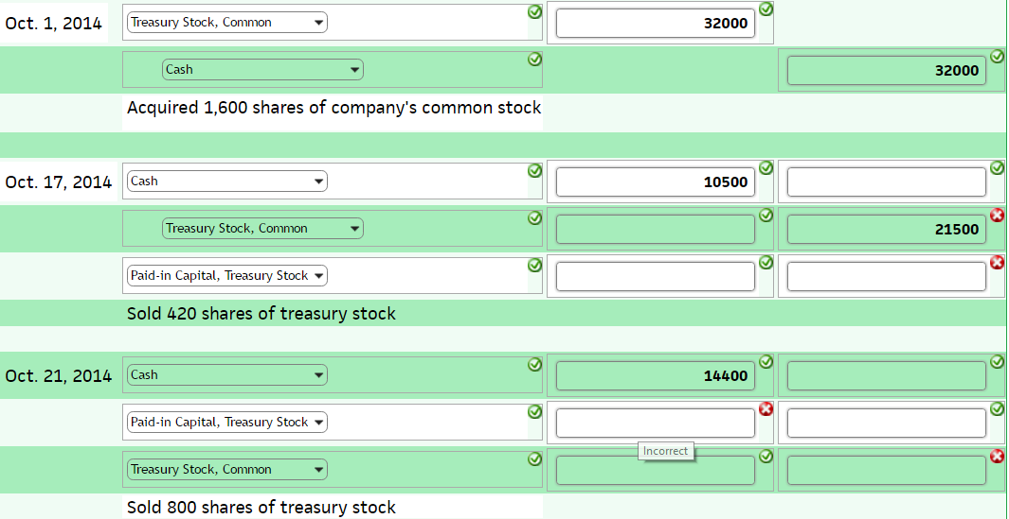

Treasury Stock Transactions
The following stock transactions of DeMeo Corporation represent all of the company's treasury stock transactions during 2014:
May 5 Purchased 800 shares of its own $2 par value common stock for $20.8 per share, the current market price.
17 Sold 400 shares of treasury stock purchased on May 5 for $22 per share.
21 Sold 200 shares of treasury stock purchased on May 5 for $20 per share.
28 Sold the remaining 200 shares of treasury stock purchased on May 5 for $19 per share.
Record DeMeo Corporation's stock transactions using T accounts. If an amount is zero, enter "0".
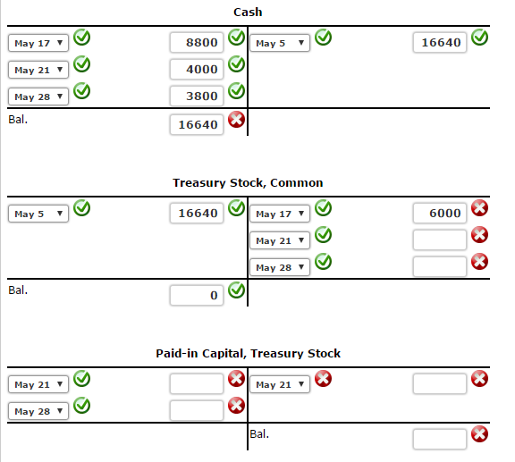

Treasury Stock Transactions Including Retirement
The following stock transactions of Carmel Corporation represent all its treasury stock transactions for the year:
June 1 Purchased 1,000 shares of its own $30 par value common stock for $70 per share, the current market price.
10 Sold 250 shares of treasury stock purchased on June 1 for $80 per share.
20 Sold 350 shares of treasury stock purchased on June 1 for $58 per share.
30 Retired the remaining shares purchased on June 1. The original issue price was $42 per share.
Record Carmel Corporation's stock transactions using T accounts. If an amount is zero, enter "0".
